Marmara University
Engineering Faculty
Department of Mechanical Engineering
ME 3000
Summer Practice Report

by
Atiba Hutchinson

I hereby declare that all information in this document has been obtained and presented in accordance with academic rules and ethical conduct. I also declare that, as require by these rules and conduct, I have fully cited and referenced all material and results that are not original to this work.

Name, Last Name :

Number :

Date :

Signature :

TABLE OF CONTENTS
Please update this table (by right clicking on the table and selecting ‘Update Field’) after you are done with the report!
1. Description of the company 4
1.1. Company Name and Location 4
1.2. Organizational Structure of the Company 4
1.3. Engineers and Their Duties 4
1.4. Main Area of Business 4
1.5. History of the Company 5
2. Introduction 6
3. Report 7
3.1. Manufacturing Processes 7
3.1.1. Welding 7
3.1.2. Cold Forging 7
3.2. Machines and Machine Tools 8
3.3. Sample Workpieces 9
3.3.1. Workpiece 1 9
3.3.2. Workpiece 2 9
3.3.3. Workpiece 3 9
3.3.4. Workpiece 4 9
3.3.5. Workpiece 5 10
3.4. Cost Analysis 11
3.4.1. Workpiece 1 11
3.4.2. Workpiece 2 11
4. Conclusion 12
5. References………………………..……………………………………………...…13
6. Appendix………………………..……………………………………………………14
A. Organizational Structure of the Company 15
B. Technical Drawing of Workpiece 1 16
C. Technical Drawing of Workpiece 2 17
D. Technical Drawing of Workpiece 3 18
E. Technical Drawing of Workpiece 4 19
F. Technical Drawing of Workpiece 5 20

Description of the company
In this chapter of the summer practice report, the company is introduced. This chapter shouldn’t be more than 3 pages.

Company Name and Location
The name of the company and its address should be provided.

Organizational Structure of the Company
The organizational structure of the company should be explained here and its schematic should be provided in the Appendix.

Engineers and Their Duties
Number of engineers (mechanical, chemical, civil, electrical, electronics, computer, etc.) and their duties should be explained in detail. You may use Table 1. You should focus more on the tasks of mechanical engineers and don’t forget to mention about the departments mechanical engineers are working.
Table 1 Number of Engineers
Engineer | Number
Mechanical
Chemical
Computer
…

Main Area of Business
In this subsection, briefly discuss the areas that the company is interested in. Please don’t copy from the company’s website, just discuss briefly with your own words.

History of the Company
A brief history of the company should be given. Please don’t copy from the company’s website, just explain briefly with your own words.

Introduction
The aim and the scope of the summer practice should be presented briefly in this chapter. This chapter shouldn’t be longer than 1 page.

Report
In this chapter, a detailed description of everything that has been done and observed during the summer practice should be given with close consideration to the program outlined by the department for the third-year students. The necessary data, tables and diagrams should be numbered and placed in the appendices.

Manufacturing Processes
Classification and a brief description of the manufacturing techniques employed in the organization (i.e. casting, chip removal processes, press work, welding, heat treatment, forging, injection molding, etc. Which of these techniques are being used, how, and for what type of work?) Please don’t explain any processes that cannot be done in the organization and don’t provided textbook stuff. You should describe the processes briefly with your own words. This subsection should be at most 6 pages.

Welding
This is just an example.

Cold Forging
This is just an example.

Machines and Machine Tools
Number of machines and machine tools (general purpose, special purpose) and their fields of use in the organization should be discussed in this subsection. Please don’t just provide tables about the properties of the machinery in the company, relate them to the manufacturing processes described in Section 3.1. This subsection should be at most 6 pages.

Sample Workpieces
Please provide the technical drawings of sample workpieces, produced on a couple of machine tools in each production unit, in the appendices. Drawings should be prepared according to the technical drawing standards (dimensions, scales, tolerances, material, engineer, etc.).
The number of sampled parts or products to be analyzed should not be less than five.
This subsection should be at most 5 pages.

Workpiece 1
A detailed explanation of every stage in the production of the sample, either closely observed or preferably performed by the student himself/herself should be given.
- First process (explain with 2-3 sentences)
- Second process
- …
Please provide routing sheets for all the workpieces similar to Table 2.
Table 2 Routing Sheet for Workpiece 1
Operation Number | Description of operation | Equipment
10
20
30
…

The technical drawing of Workpiece 1 is provided in Appendix B.

Workpiece 2
A detailed explanation of every stage in the production of the sample, either closely observed or preferably performed by the student himself/herself should be given.
Table 3 Routing Sheet for Workpiece 2
Operation Number | Description of operation | Equipment
10
20
30
…

Workpiece 3
A detailed explanation of every stage in the production of the sample, either closely observed or preferably performed by the student himself/herself should be given.
Table 4 Routing Sheet for Workpiece 3
Operation Number | Description of operation | Equipment
10
20
30
…

Workpiece 4
A detailed explanation of every stage in the production of the sample, either closely observed or preferably performed by the student himself/herself should be given.
Table 5 Routing Sheet for Workpiece 4
Operation Number | Description of operation | Equipment
10
20
30
…

Workpiece 5
A detailed explanation of every stage in the production of the sample, either closely observed or preferably performed by the student himself/herself should be given.
Table 6 Routing Sheet for Workpiece 5
Operation Number | Description of operation | Equipment
10
20
30
…

Cost Analysis
In this subsection, cost analyses of the two sample parts should be given. Direct and indirect costs should be considered and there should be explanations about each item. If the company is not willing to give you the necessary costs, then use fictitious numbers and complete the cost analyses. This subsection should be at most 2 pages.

Workpiece 1

Workpiece 2

Comment about the manufacturing times, costs, etc. What can be done to reduce cost and manufacturing time of the corresponding parts?

You may follow the below approach to determine the costs of the parts.
where
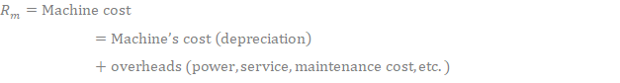
where

Note that
Production cost (depends on speed and feed)
Tool changing cost (depends on tool wear)
Tool cost (depends on tool wear)

Conclusion
In this chapter, the data obtained and the experience gained during the summer practice should be assessed, recommendations should be made. This last chapter shouldn’t be longer than 1 page.

Appendices
All related data, tables and drawings should be given in this section.

Organizational Structure of the Company

Technical Drawing of Workpiece 1
Please use the template provided here
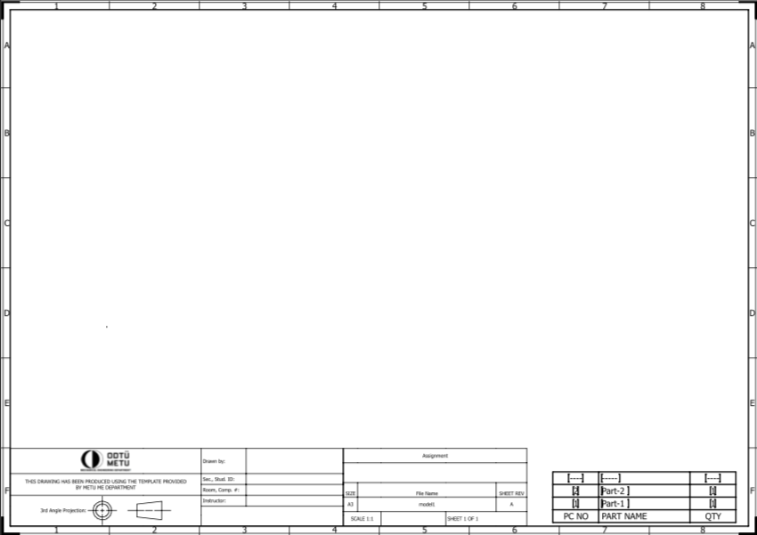

Technical Drawing of Workpiece 2
Please use the template provided here.

Technical Drawing of Workpiece 3
Please use the template provided here.

Technical Drawing of Workpiece 4
Please use the template provided here.

Technical Drawing of Workpiece 5
Please use the template provided here.

