**CS-102**

**MODÜLER SOĞUTMA EĞİTİM SETİ**

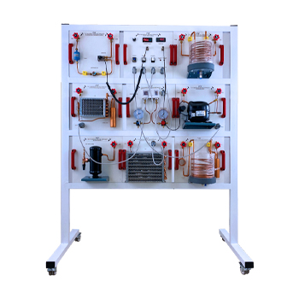

ADF. Mühendislik Danışmanlık San.Tic.Ltd.Şti

Akse Mah. Rahmi Dibek Cad. No:207 Çayırova/Kocaeli/TÜRKYE

Phone:+90 (262) 744 04 35E-mail:info@adfmhendislik.com

Web :http://www.adfmuhendislik.com

İçindekiler

1. Giriş………………………………………………………………………………………….. 1

1.1 Cihazın amacı, öğrenme hedefleri………………...............................3

2 Emniyet……………………………………………………………………………………….3

2.1 Kullanım amacı…………………………………………………………………………3

2.2 Güvenlik talimatlarının yapısı………………………………………………….. 3

2.3 Güvenlik talimatları…………………………………………………………………..4

2.4 Çalıştırma ve saklama yeri için ortam koşulları…………………………..6

3 Cihazın açıklaması………………………………………………………………………..6

3.1 Cihaz bölümleri………………………………………………………………………….7

3.2 Deney düzeneği modülleri ve elemanları…………………………………..8

3.3 Kontrol elemanları…………………………………………………………………….9

3.4 Modüler soğutma eğitim seti bileşenleri………………………………….10

3.4.1 Hermetik pistonlu pistonlu kompresör……………………………….. 11

3.4.2 Kondenser…………………………………………………………………………….12

3.4.3 Evaporatör……………………………………………………………………………13

3.34.4 Termostatik genleşme valfi (TGV)……………………………………….14

3.4.5 Likit tankı (Receiver)……………………………………………………………..15

3.4.6 Filtre / kurutucu…………………………………………………………………….15

3.4.7 Debimetre…………………………………………………………………………….16

3.4.8 Kombine basınç anahtarı……………………………………………………………….16

3.4.9 Gözetleme camı……………………………………………………………………17

3.5 İlk işletmeye alma…………………………………………………………………...18

3.6 Devreye alma………………………………………………………………………….18

3.7 Soğutma sisteminin kapatılması……………………………………………..18

3.8 Bakım………………………………………………………………………………………18

4.Temel ilkeler………………………………………………………………………………19

4.1 Soğutma teknolojisinin temel ilkeleri………………………………………..19

4.2 Soğutma prensibi………………………………………………………………………19

4.3 Log p-h diyagramında termodinamik döngü…………………………......21

4.3.1 Farklı buharlaşma basınçlarında paralel çalışmada log p-h diyagramı….21

4.3.2 Bir evaporatörün bağımsız çalışması için ideal log p-h diyagramı…………22

4.4.Kapasite hesabı ………………………………………………………………………....22

4.4.1 Soğutma kapasitesi…………………………………………………………………..22

4.4.2 Kondenser kapasitesi……………………………………………………………….23

4.4.3 Kompresör kapasitesi……………………………………………………………….24

4.4.4 Performans katsayısı hesabı………………………………………………………24

5 Çalışma Sayfaları …………………………………………………………………………….24

5.1Deneyler………………………………………………………………………………………..24

5.1 Deney no1……………………………………………………………………………………26

5.2 Deney no 2……………………………………………………………………………………29

5.3 Deney no 3……………………………………………………………………………………33

6.Uygulamalı deneyler………………………………………………………………………..35

6.1Deney no 1………………………………………………………………………………………35

6.1.1 Deneyin yapılışı……………………………………………………………………………35

6.1.2 Deneye başlama………………………………………………………………………….36

6.1.3 Ölçülen değerler…………………………………………………………………………36

6.1.4 Sistem özelliklerinin hesaplanması……………………………………………..37

6.1.5 Kondenser kapasitesi ………………………………………………………………….37

6.1.6 Kompresör kapasitesi…………………………………………………………………..37

6.2 Deney 4 Su soğutmalı sistemin termodinamik döngüsü…………………..38

6.2.1 Deneyin yapılışı……………………………………………………………………………..38

6.2.2 Hesaplamalar ve performans karşılaştırması…………………………………39

6.2.3 Soğutma kapasitesinin hesaplanması…………………………………………….40

6.2.4 Performans katsayısının hesaplanması…………………………………………..41

7. Ek………………………………………………………………………………………………………42

7.1 Teknik veriler……………………………………………………………………………………42

|  |  |
| --- | --- |
| **Symbols** | **Meaning** |
|  | Compressor |
|  | Expansion Valve |
|  | Condenser |
|  | Evaporator (Air) |
|  | Evaporator (Water) |

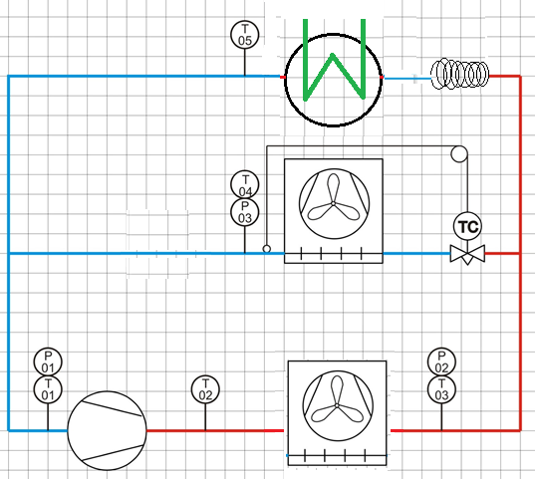

1. Log p-h diagram of the cycle:

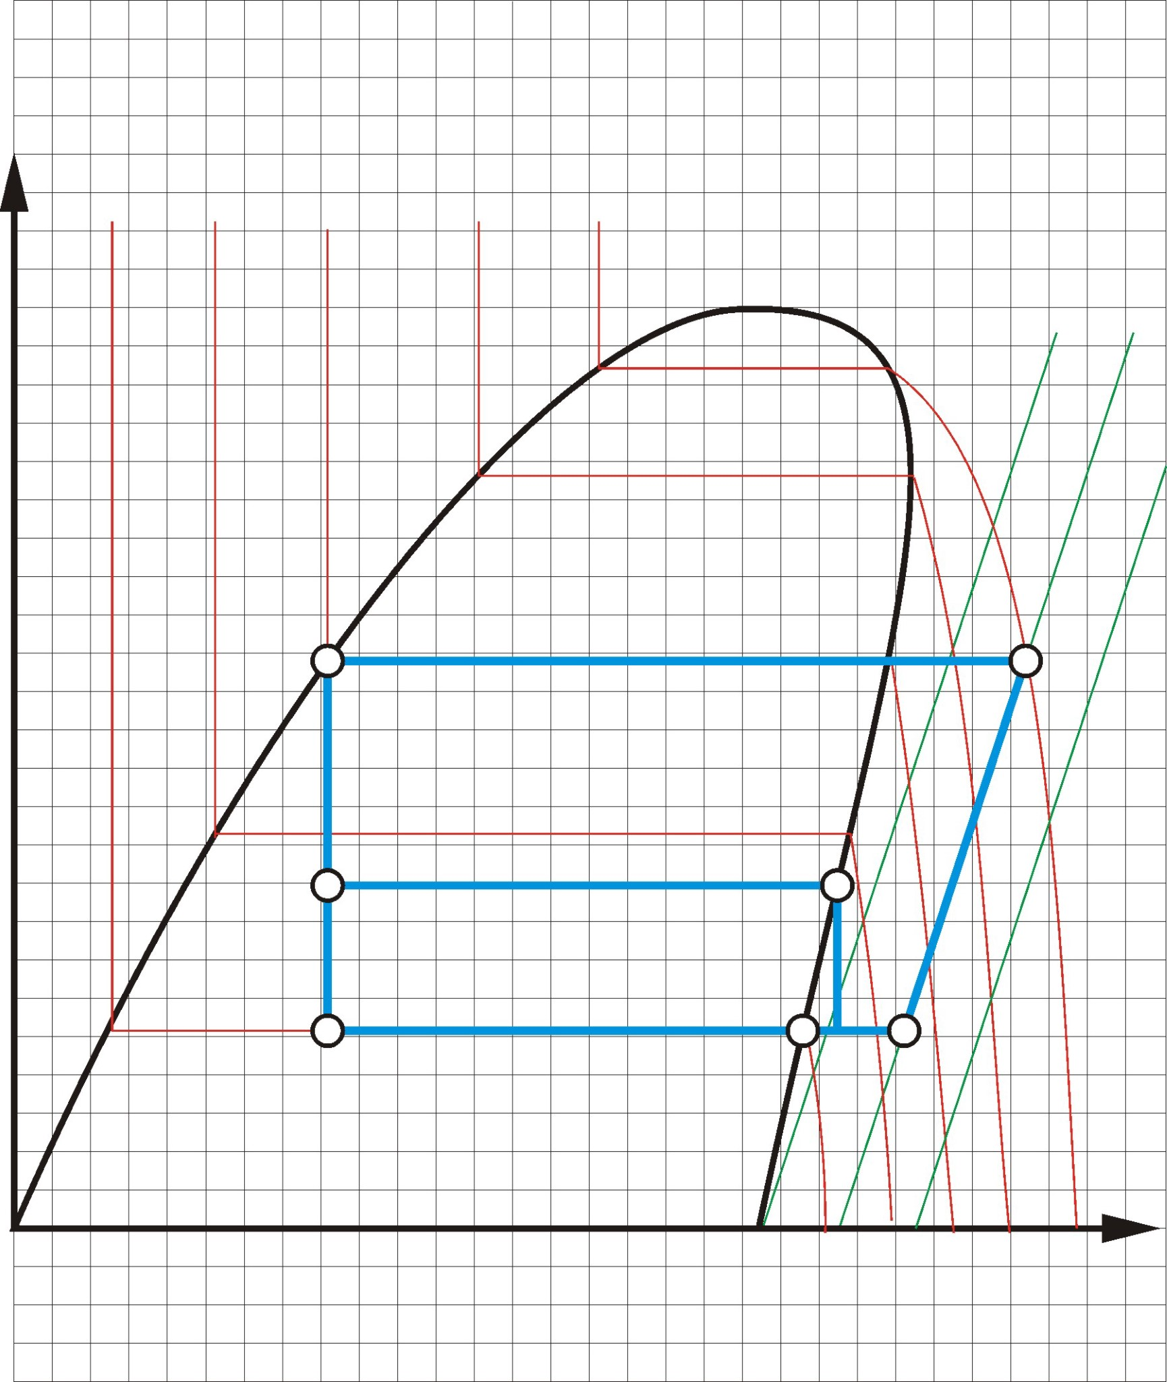

***p***

***2***

***p***

***3***

***p***

***1***

***t***

***3***

***t***

***4***

***t***

***5***

***t***

***1***

***t***

***2***

*P1*

En düşük basınç (Derin dondurucu)

***h***

***log p***

İkinci en düşük basınç (Standart evaporatör)

En yüksek basınç (Kondenser)

*P3*

*P2*

**1. Condenser experiment**

* Perform the temperature and pressure measurements
* Compute the rate of heat transfer from the condenser to air
* Repeat the identical procedure for the condenser with water cooler.

**1.1. Experiment**

• Turn on the system.

• Turn on the fan of the evaporator.

* Fill in the working fluid of the condenser.

• Turn on the compressor.

• Wait till the system reaches steady flow conditions. (Stable pressure is seen at the compressor inlet).

* Measure and note all the necessary system properties (temperature and pressure at the condenser inlet and outlet, mass flow rate of the refrigerant).

NOTE: Manometers do not indicate absolute pressures. Hence, add the atmospheric pressure to the manometer pressure.

**1.2 Measurement**

|  |  |  |  |  |  |  |
| --- | --- | --- | --- | --- | --- | --- |
| Temperature | Measured temperature (oC) | Pressure | Measured pressure (bar) | Volume flow rate (m3/s) (lt/h) | Mass flow rate (kg/s) | Enthalpy (kJ/kg) |
| T1 |  | P1 |  |  |  |  |
| T2 |  | P2 |  |  |  |  |
| T3 |  | P3 |  |  |  |  |
| T4 |  | P4 |  |  |  |  |

**2.** **Evaporator experiment**

Repeat the identical procedure for the evaporator.

|  |  |  |  |  |  |  |
| --- | --- | --- | --- | --- | --- | --- |
| Temperature | Measured temperature (oC) | Pressure | Measured pressure (bar) | Volume flow rate (m3/s) (lt/h) | Mass flow rate (kg/s) | Enthalpy (kJ/kg) |
| T1 |  | P1 |  |  |  |  |
| T2 |  | P2 |  |  |  |  |
| T3 |  | P3 |  |  |  |  |
| T4 |  | P4 |  |  |  |  |

**3.** **Compressor experiment**

* Compute the power consumption of the compressor using the rate of heat transfer for the condenser and the evaporator.
* Measure the pressure and the temperature at the inlet and the outlet of the compressor.
* Compute the isentropic efficiency of the compressor.

|  |  |  |  |  |
| --- | --- | --- | --- | --- |
| Temperature | Measured temperature (oC) | Pressure | Measured pressure (bar) | Enthalpy (kJ/kg) |
| T1 |  | P1 |  |  |
| T2 |  | P2 |  |  |
| Isentropic case |  |  |  |  |
| T3 |  | P3 |  |  |
| T4 |  | P4 |  |  |
| Isentropic case |  |  |  |  |